Q4

Apply GA based approach to solve an instance of Travelling Salesman problem.

Problem:

Given a set of cities and distance between every pair of cities, the problem is to find the shortest possible route that visits every city exactly once and returns to the starting point.

Pseudo Code:

1. Initialize the population randomly.
2. Determine the fitness of the chromosome.
3. Until done repeat:
   1. Select parents.
   2. Perform crossover and mutation.
   3. Calculate the fitness of the new population.
   4. Append it to the gene pool.

Trace:

Input Dataset,

|  |  |  |  |  |  |
| --- | --- | --- | --- | --- | --- |
|  | 0 | 1 | 2 | 3 | 4 |
| 0 | 0 | 2 | inf | 12 | 5 |
| 1 | 2 | 0 | 4 | 8 | Inf |
| 2 | inf | 4 | 0 | 3 | 3 |
| 3 | 12 | 8 | 3 | 0 | 10 |
| 4 | 5 | inf | 3 | 10 | 0 |

Let encoding be in such a way that 012340 means he is travel travelled from 0 to 1 to 2 to 3 to 4 to 0.

And the cost of this path will be fitness. Let the Population size be 10. Initial Temperature be 10000. And before mutating each generation, lets sort based on fitness in ascending order. We are going to run this algo for 5 generations.

New temperature = 0.9 * (Old temperature)

Initial Generation,

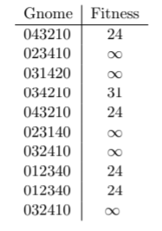

For our mutation, let’s take a 2 random position of a gene in the current population and swap them.

This new gene will only get accepted if its fitness is less than its parents, or if its Boltzmann probability is greater than 0.5.

So, our current gnome is 043210 with fitness score of 24. The first mutated gene is 043120 with fitness score of infinity.

Clearly, the fitness of the child is greater than the parent, therefore we need to calculate the probability. By formula, we get prob = 0.

Therefore, we reject this child and calculate another, the next mutated child gnome is 013240 with fitness score of 21. As the child is fitter than the parent, we send them to the next gen.

Similarly do for the rest, to show the use of probability, So, our current gnome is 012340 with fitness score of 24. The first mutated gene is 012430 with fitness score of 31.

Clearly, the fitness of the child is greater than the parent, therefore we need to calculate the probability. By formula, we get prob = 0.999305.

Therefore, we accept this child into the next generation. This way, we get,

Gen 1,

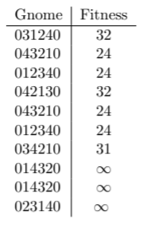

Tnew = 9000 - Gen 2, Tnew = 8100 - Gen 3,

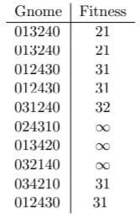 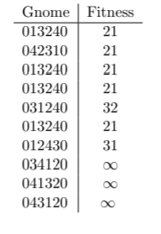

Tnew = 7290 - Gen 4, Tnew = 6561 - Gen 5,

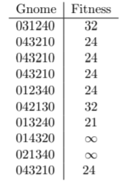 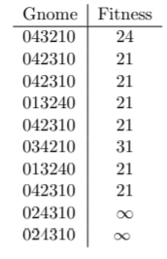

It’s clear from the 5th generation that the minimum distance is 21 and 034210 can be one of the possible solutions.